**Teacher Introduction To Code Trather**

**Table of Contents**

Revision History **2**

Forward**3**

Grading Assignments**4**

**Revision History**

|  |  |  |  |
| --- | --- | --- | --- |
| **Date** | **Version #** | **Author** | **Description** |
| 4/12/2023 | 1.0 | Meagan | Initial Draft |

**The following document has been developed to help guide the teacher with an overview of Code Trather. The teacher will find a walkthrough of decrypting a student’s submitted file and finding patterns in a class’s submissions.**

|  |
| --- |
| **Grading Assignments** |

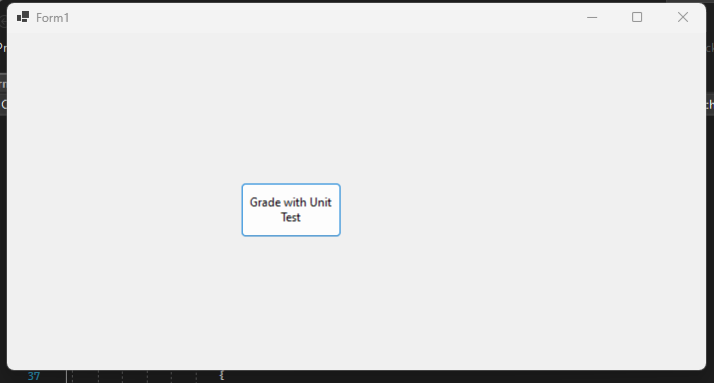

Figure 1

1. Navigate to where you have the program saved and double click on it. Upon opening, the window in Figure 1 will show.
2. After clicking Grade with Unit Test, two dialog boxes will open. In the first box you select your unit test file and in the second dialog box you select the folder containing all the students’ assignments. See Figures 2 and 3 for examples.

Figure 2

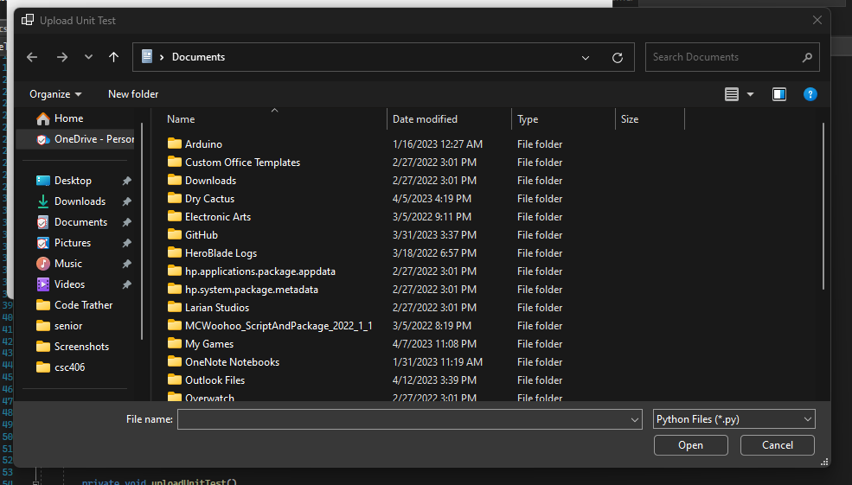

Figure 3

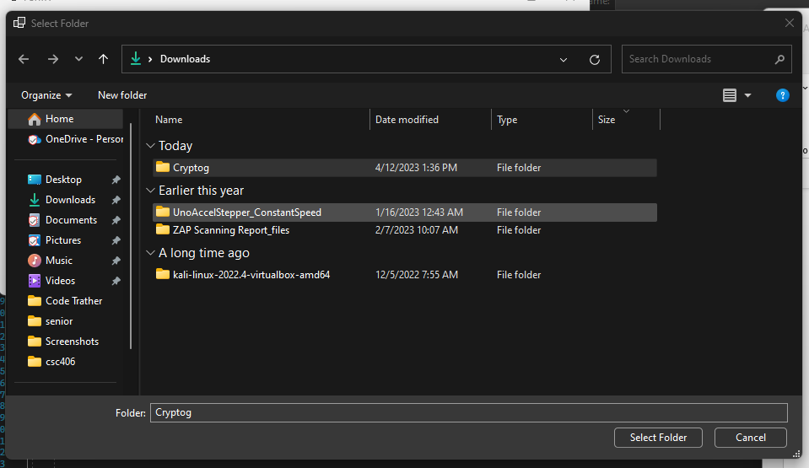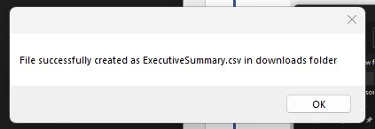

Figure 5

1. After opening the folder containing students’ assignments, the dialog box seen in Figure 4 will show. You will find an Executive Summary containing the names and grades of all students. Also shown in Figure 5, you will find a copy of the unit test you provided.

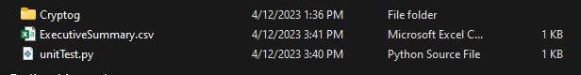

Figure 6